Task 1: Install Nginx and Run Nginx on Port Number 81
Outcome
Nginx is installed and running on port 81. The Nginx welcome page is accessible through http://SERVER_IP:81.
Objective
To install the Nginx web server and configure it to listen on port 81 instead of the default HTTP port 80.
Prerequisites
- Linux virtual machine or server (Ubuntu or Amazon Linux).
- User account with sudo privileges.
- Internet connectivity.
- Port 81 available for use.
Step-by-Step Implementation
Step 1: Check the Operating System
Implementation:
Open the Linux terminal and execute:
cat /etc/os-release
Identify whether the server is running Ubuntu or Amazon Linux.
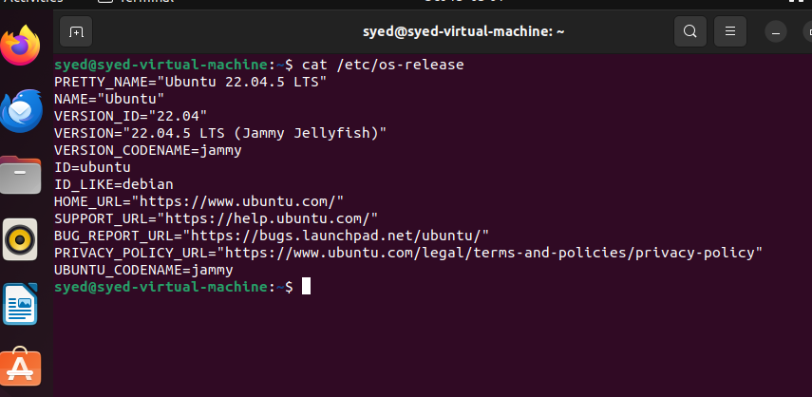Step 2: Install Nginx
For Ubuntu:
sudo apt update
sudo apt install nginx -y
For Amazon Linux 2023:
sudo dnf install nginx -y
Configuration Table
Parameter | Value
Software | Nginx
Package name | nginx
Installation method | APT or DNF
Required access | Sudo privileges
Verify the installation:
nginx -v

Step 3: Configure Nginx to Use Port 81
For Ubuntu:
Open the default configuration file:
sudo vi /etc/nginx/sites-available/default
Find the line:
listen 80 default_server;
Change it to:
listen 81 default_server;
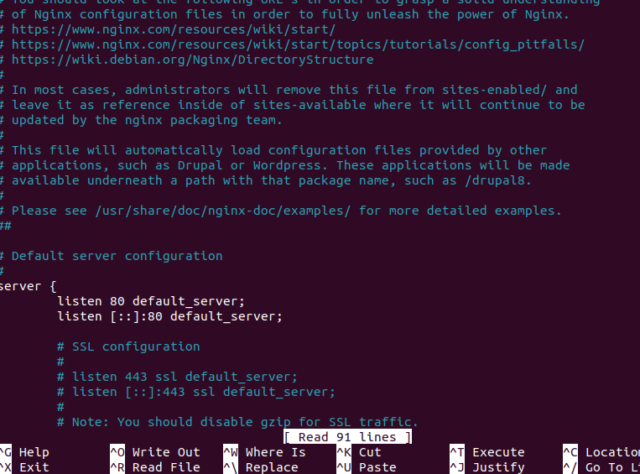
Save and exit by pressing Esc, typing :wq, and pressing Enter.
For Amazon Linux:
Open the configuration file:
sudo vi /etc/nginx/nginx.conf
Inside the appropriate server block, change:
listen 80;
to:
listen 81;
Save and exit.
Configuration Table
Parameter | Value
Web server | Nginx
Default port | 80
Required port | 81
Configuration directive | listen 81;
Screenshot Evidence
Step 4: Test the Configuration
Execute:
sudo nginx -t
Expected result: The configuration syntax is valid and the test is successful.
Screenshot Evidence
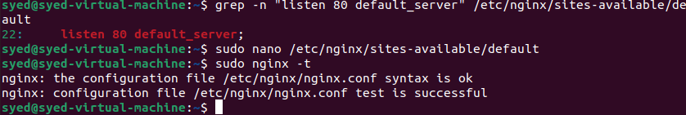Step 5: Start and Enable Nginx
Execute the following commands:
sudo systemctl enable nginx
sudo systemctl restart nginx
sudo systemctl status nginx
Expected result: Nginx displays active (running).
Screenshot Evidence
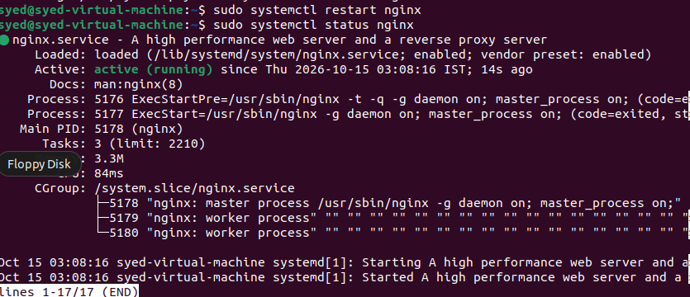
Step 6: Allow Port 81
If UFW is enabled on Ubuntu, execute:
sudo ufw allow 81/tcp
For an AWS EC2 instance, navigate to:
AWS Console → EC2 → Instances → Select Instance → Security → Security Groups → Edit Inbound Rules
Add the following rule.
Parameter | Value
Type | Custom TCP
Protocol | TCP
Port range | 81
Source | Your IP address or approved network
Screenshot Evidence
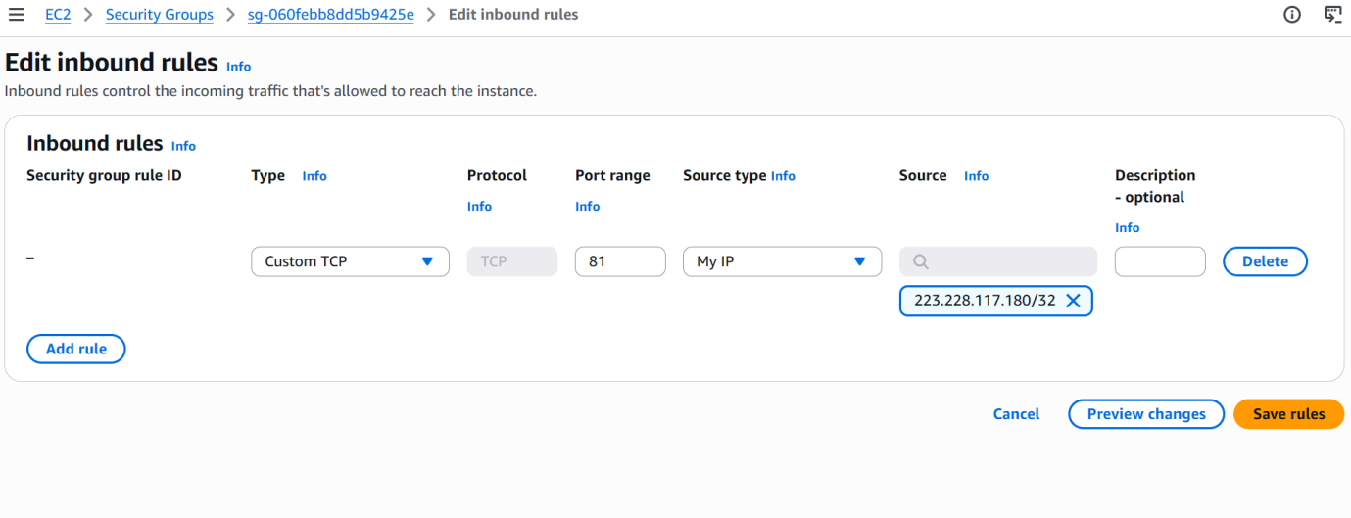Validation Steps
Execute:
sudo systemctl is-active nginx
sudo ss -lntp | grep ':81'
curl http://localhost:81
Expected results:
- Nginx service returns active.
- Nginx is listening on port 81.
- The curl command returns the website's HTML content.
- 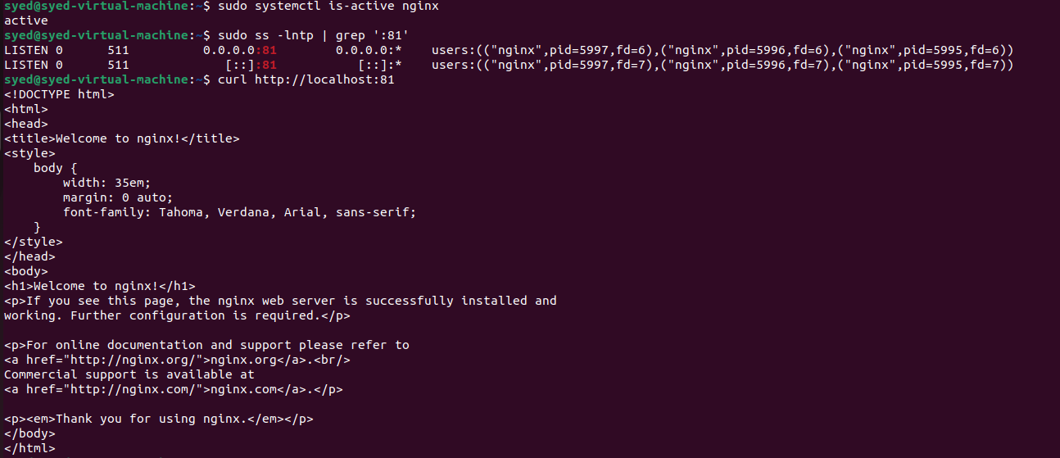
Open a browser and enter:
http://SERVER_IP:81
Replace SERVER_IP with your server's actual IP address.
Validation Screenshot
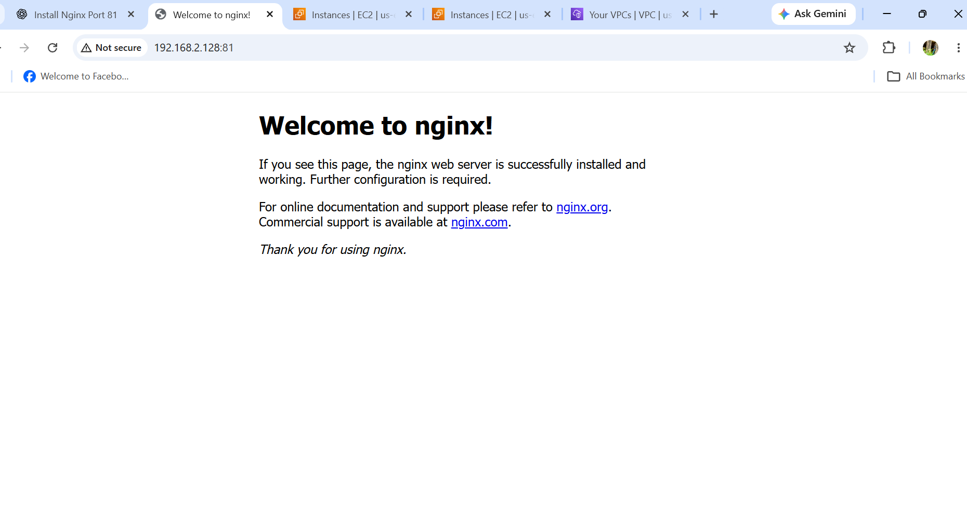Explanation
Nginx is a web server used to deliver website content and handle HTTP requests. By default, Nginx listens on port 80. Changing the listening directive to port 81 allows the web server to accept requests on the custom port.
The Nginx configuration must be valid, the service must be running, and the firewall must allow port 81 for remote access.
Real-Time Use Case
Organizations use Nginx to host websites, serve static files, and act as a reverse proxy. Running a service on port 81 can be useful for testing websites or hosting a separate web service alongside another service using port 80.
Common Errors and Troubleshooting
Error | Cause | Resolution
nginx: command not found | Nginx is not installed | Install Nginx using the appropriate package manager
bind() failed | Port 81 is already in use | Check with sudo ss -lntp and resolve the port conflict
Configuration test fails | Incorrect Nginx syntax | Correct the configuration and run sudo nginx -t
Connection refused | Nginx is stopped or not listening on port 81 | Restart Nginx and verify its listening port
Website timeout | Firewall or AWS security group blocks port 81 | Allow TCP port 81
Website opens on port 80 | Configuration still uses port 80 | Update the correct server block and restart Nginx

